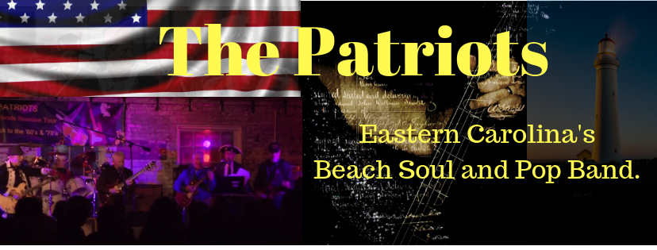
The Patriots unique style of Beach Music included such classics as My Girl, Midnight Hour, Knock On Wood, Slip Away, and a solid hour of fast paced dance songs. They entertain crowds that dance every song all night long. This Group of talented musician includes, guitar, keyboards, bass, drums and horns along with great vocals to match each song in their playlist. Bring THE PATRIOTS to your stage and you will look forward to having them back.
